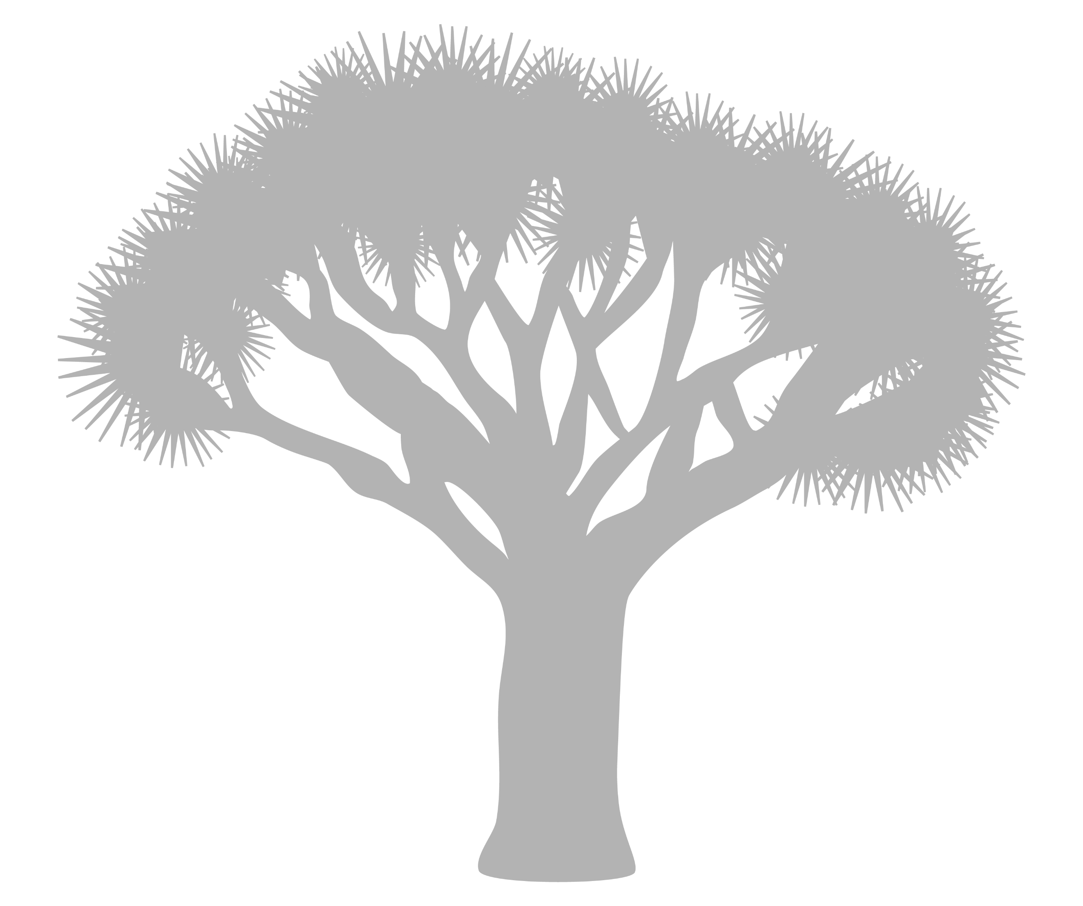


TEMPLATE

- Presentation Title:

- Authors’ names followed by email addresses (there is no limit to the number of authors):
Author 1:
Author 2:
Author 3:
Author 4:
Author 5:
Author 6:
…

- Type of presentation:
Poster presentation Oral presentation

- Panel (select up to two panels):

- Non-Invasive and Non-Destructive Analytical Approaches
- Digital and Sustainable Innovation in Cultural Heritage
- Development of Advanced Technological Tools
- Sustainable Conservation Materials and Environmental Management
- Digital Heritage and Collection Management

Title (16 pt, bold, Arial, Centered)

Authors (12 pt, Arial, Centered), e.g.: author 1 surname, given name¹, author 2 surname, given name²,…e.g: Picasso, Pablo¹, Kahlo, Frida², …
Authors (10 pt, italic, arial, align left), author address, e.g.:
- HERCULES Laboratory, In2PAST Laboratory (Associate Laboratory for Research and Innovation in Heritage, Arts, Sustainability and Territory, Institute for Advanced Studies and Research), University of Évora (Portugal)
- Raman Spectroscopy Research Group, Department of Chemistry, Ghent University (Belgium)
- …
Presenting author email (size 10, align left):
All abstracts must follow these guidelines to ensure clarity and uniformity, while allowing creative presentation:
- Format & Layout
A4 page with 2.5 cm margins on all sides.
Font: Arial (or similar).
Line spacing: single-spaced for main text, 10 pt for captions and references.
- Text Structure
Title: 16 pt, Bold, followed by an empty line.
Author names: 12 pt, followed by an empty line.
Affiliations: 10 pt, Italics.
Presenting author’s email: 10 pt, followed by an empty line.
Main text: 12 pt, Justified.
Figures / Graphical Abstracts: Permitted (send separately in JPEG/ PNG/ TIFF format, minimum 300 dpi for color or grayscale images); captions 10 pt.
References and Acknowledgements: 10 pt.
- Submission
Abstracts should fit this A4 page.
Submit in .pdf and .docx (or equivalent editable format).
Indicate ORAL or POSTER presentation preference. If unspecified, POSTER will be assumed.
Abstracts should be sent to: inart2026@uevora.pt

References – ACS style (10 pt, Arial, left aligned). e.g.Journal Articles: [1] Author 1, A.B.; Author 2, C.D. Title of the article. Abbreviated Journal Name Year, Volume, page range.
Acknowledgements (10 pt, justified)

